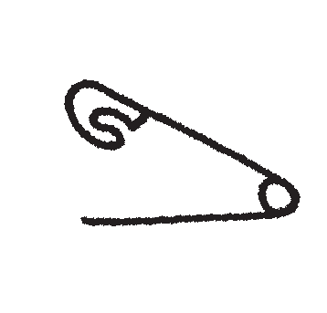
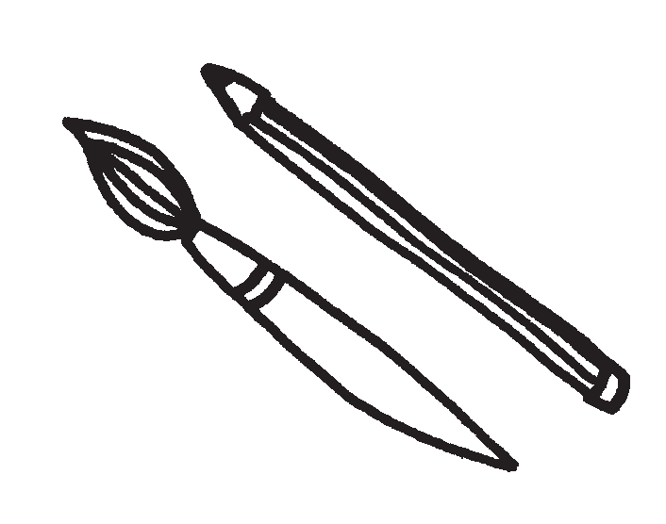
JOIN US FOR THE ANNUAL
SPIRITRIDGE ELEMENTARY

FRIDAY, DEC. 13th 6:30-8:00pm
Hand-crafted works from students and local artists.
Sign up to reserve your booth today @ www.spiritridge.org
Support our school and community and do some holiday shopping. Questions: artsandcrafts@spiritridge.org
SEE BACKSIDE FOR MORE DETAILS AND RULES

Dear students and parent/guardian participants,

Welcome to the Spiritridge 2019 Arts and Crafts Fair!

Please be aware of the following information:

- Please go to www.spiritridge.org website for student booth and parents volunteering registration.

- All vendors need to check in at the entrance before entering the MPR.

- Please bring tablecloth, paper, pens, scissors and tape etc. to decorate your booth if needed.

- Please list all ingredients if you are selling food items.

- This is not a drop off event. Children must be with an adult.

- No appliances that need to be plugged in allowed in the event.

Setting up tables 6pm-6:15pm
Vendors come in to set up booth 6:15pm-6:30pm
Event starts at 6:30pm, ends at 8pm

More questions, please contact artsandcrafts@spiritridge.org

Thank you for your attention!

